**EXPERIMENT-5**

#include<stdio.h>

int at[100];

int bt[100];

int ft[100];

int tat[100];

int wt[100];

int index[100];

void swap(int i,int j){

int temp;

temp=at[i];

at[i]=at[j];

at[j]=temp;

temp=bt[i];

bt[i]=bt[j];

bt[j]=temp;

temp=index[i];

index[i]=index[j];

index[j]=temp;

}

void bubblesort(int n){

int i,j;

for(i=0;i<n-1;i++){

for(j=0;j<n-i-1;j++){

if(at[j]>at[j+1]){

swap(j,j+1);

}

}

}

}

void make_ft(int n){

int i;

ft[0]=at[0]+bt[0];

for(i=1;i<n;i++){

ft[i]=ft[i-1]+bt[i];

}

}

void make_tat_wt(int n){

int i;

for(i=0;i<n;i++){

tat[i]=ft[i]-at[i];

wt[i]=tat[i]-bt[i];

}

}

int main(){

int n,i;

char a[7][100]={"S.no","AT","BT","FT","TAT","WT"};

scanf("%d",&n);

for(i=0;i<n;i++){

index[i]=i;

scanf("%d %d",&at[i],&bt[i]);

}

bubblesort(n);

make_ft(n);

make_tat_wt(n);

printf("%3s %3s %3s %3s %3s %3s\n",a[0],a[1],a[2],a[3],a[4],a[5]);

for(i=0;i<n;i++){

printf("%4d%4d%4d%4d%4d%4d\n",index[i],at[i],bt[i],ft[i],tat[i],wt[i]);

}

return 0;

}

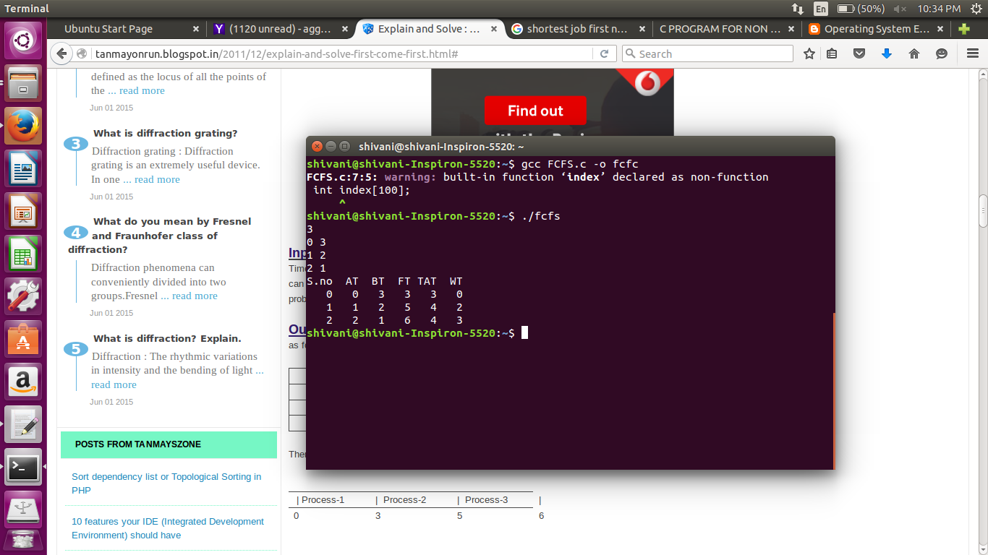

**EXPERIMENT-6**

#include<stdio.h>

typedef struct nonpresjf

{

int at,bt,ft,tat,wt;

}

nonpresjf;

nonpresjf p[20],p1[20];

int main()

{

int i,limit,nextval,m,min,n;

p[0].wt=p[0].tat=0;

printf("\n Enter the no of process: ");

scanf("%d",&n);

for(i=1;i<=n;i++)

{

printf("Enter the arrival time: ");

scanf("%d",&p[i].at);

}

limit=p[1].at;

for(i=1;i<=n;i++)

{

printf("Enter the burst time: ");

scanf("%d",&p[i].bt);

}

for(i=1;i<=n;i++)

limit+=p[i].bt;

for(i=1;i<=n;i++)

p1[i]=p[i];

printf("\n\nGantt chart is as follows: ");

printf("%d",p[1].at);

nextval=p[1].at;

m=1;

do

{

min = 9999;

for(i=1;p[i].at<=nextval && i<=n ;i++)

if(p[i].bt<min && p[i].bt>0)

{

m=i;

min=p[i].bt;

}

nextval+=p[m].bt;

p[m].bt=0;

printf("->P%d->%d",m,nextval);

if(p[m].bt==0)

{

p[m].ft=nextval;

p[m].tat=p[m].ft-p[m].at;

p[m].wt=p[m].tat-p1[m].bt;

p[0].tat+=p[m].tat;

p[0].wt+=p[m].wt;

}

}while(nextval<limit);

p[0].tat=p[0].tat/n;

p[0].wt=p[0].wt/n;

char a[7][100]={"","S.no","AT","BT","FT","TAT","WT"};

printf("\n%3s %3s %3s %3s %3s %3s\n",a[1],a[2],a[3],a[4],a[5],a[6]);

for(i=1;i<=n;i++)

printf("\n%4d%4d%4d%4d%4d%4d\n",i,p[i].at,p1[i].bt,p[i].ft,p[i].tat,p[i].wt);

return 0;

}

